MCADAMS LADY GATOR CROSS COUNTRY SCHEDULE
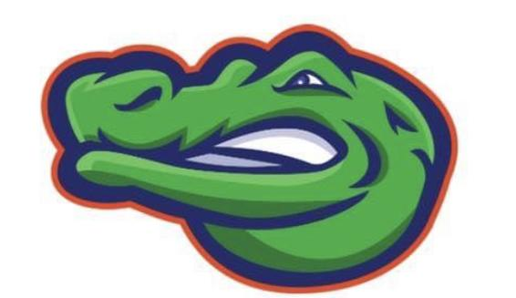
First practice October 20th

DATE HOST OPPONENTS
Oct 30th CLEAR LAKE INTERMEDIATE VLIS, SCIS, CIS, LCIS, MJHS, KJH
Nov 6th SPACE CENTER INTERMEDIATE LCIS, BYIS, BIS, CIS, SIS, MJH
Nov 13th MCADAMS JH KJH, DJH, FJH, BYIS, LCIS, CCIS
Nov 29th Challenger ALL
Dec 5th Challenger ALL

*Races start at 4:45 or once all teams are present
*Race Order: 7th Grade, followed by 8th grade

